Simple Tutorial for making a Waterfall

Important Note: the files used in the making of this tutorial are from the site Just Walls and Floors Yahoo Group…the files are not my creation.

Step !:

Begin by creating a wall for the terrain paint to be applied. This terrain paint will work better on a flat surface as opposed to one with lots of hills, or rocks sticking out from the wall.

See example 1: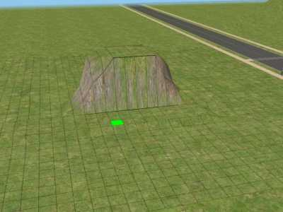

Step 2:
Here you will apply the base of your waterfall….there are numerous paints you can use for this. I have chosen the bluish green from just walls and floors yahoo group.

Example 2: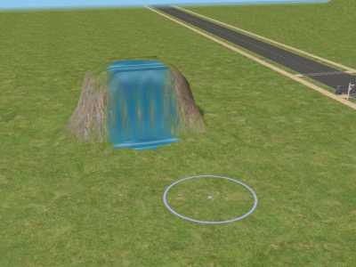
After painting your base color onto the hillside. You r next step is to paint on the foam or spray. Once again, this terrain paint is from just walls and floors yahoo group. The terrain paint will completely cover your base cover of paint if you hold the buttons too long to place it. If you completely cover it go back to step 2 and start over….
Example 3: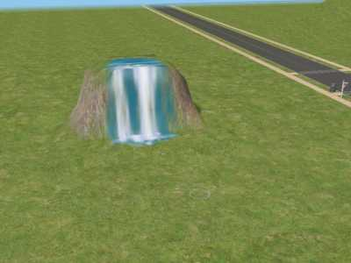

At this point you are ready to go in and touch up your waterfall. This is your conception of what a waterfall should look like. Use the small setting on the terrain paint and use it sparingly.

Example4: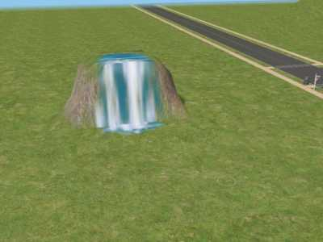

This is your basic waterfall….you can use the terrain paints to touch it up anyway you would like. Now you are ready to add greenery or rocks to your waterfall. In these two pictures I have added two different types of trees to the waterfall:
Example 5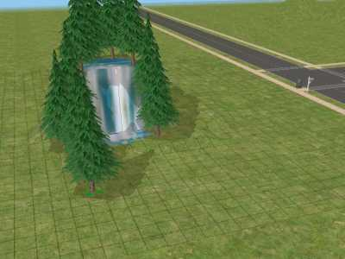

Example 6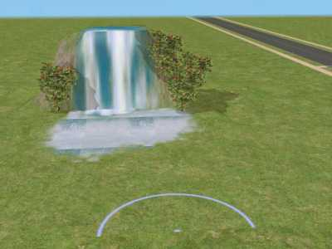

In example 6 you will also see where I have added the bubbly terrain paint from just walls and floors yahoo group. From this point on you can use your imagination to add water at the base of the waterfall. Remember if you use the water tool so that your waterfall falls into a pool or river, then you want to place that first because if you get too close to the waterfall in placing it later it can mess up the terrain paints by leveling the ground.

For example I have created a pool using the terrain paints and surrounded it with rocks, which is also a terrain paint.
Example7: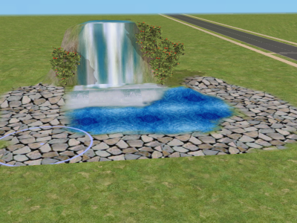

Now you too can have a waterfall in your sims homes. You are only limited by your imagination! Have fun!
Jim bob

